**Prerequisite to create Load Balancer:**

1. EC2 Instance
2. Target Group
3. Certificate (we need to create in AWS certificate manager (ACM)).

**Step to create load balancer using Https:**

1. Create two ec2 instances with public IP.
2. Create Security group to allowed port number.
3. Then goto EC2 dashboard, from left side clicks on load balancer.

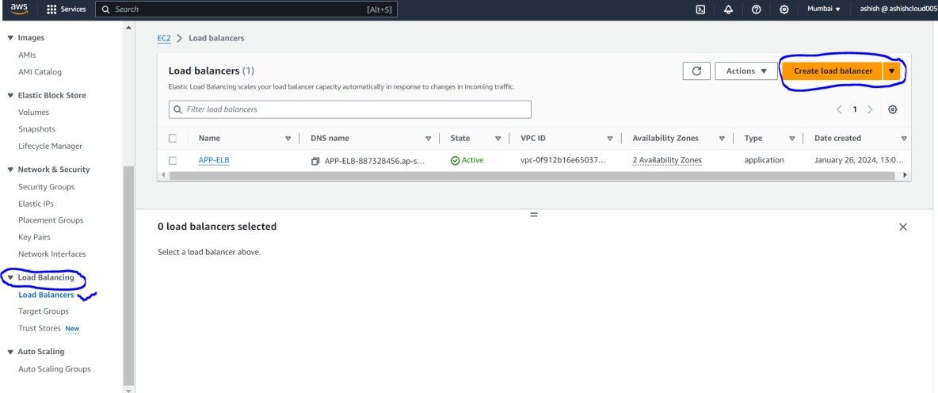

1. Then from Compare and select load balancer type, goto **Load balancer types and then select Application Load Balancer(select load balancer based on your requirement)  
     
   Note : for spring boot application select Application Load Balancer**
2. **Then click on create.**

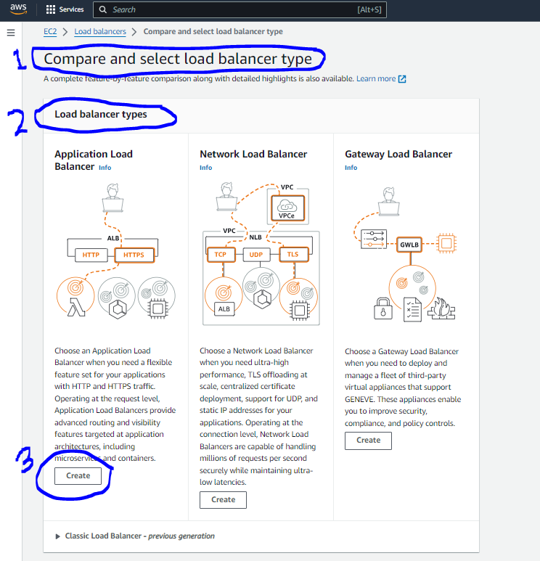

1. In **Create Application Load Balancer** goto **Basic configuration** and enter **Load balancer name**.
2. In **Scheme** select **Internet-facing** and in **IP address type** select **IPv4**

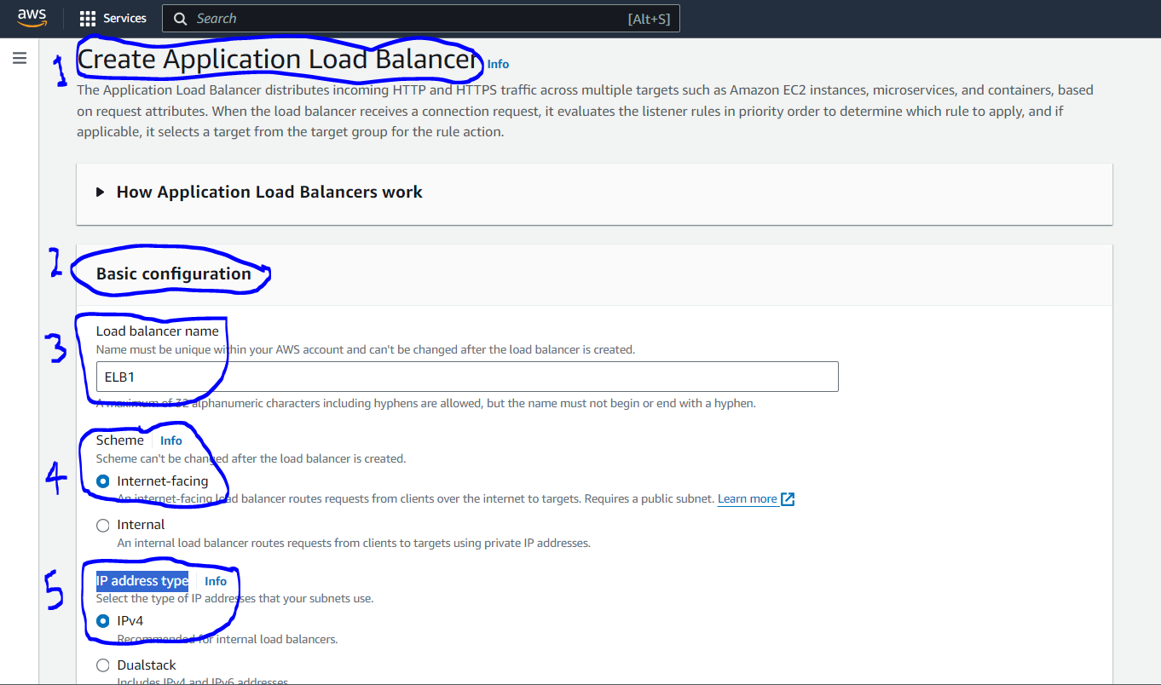

1. Then Goto **Networking Mapping.**
2. **Select VPC.**
3. Then in **Mappings** select **availability zone**(select AZ based on your requirement).

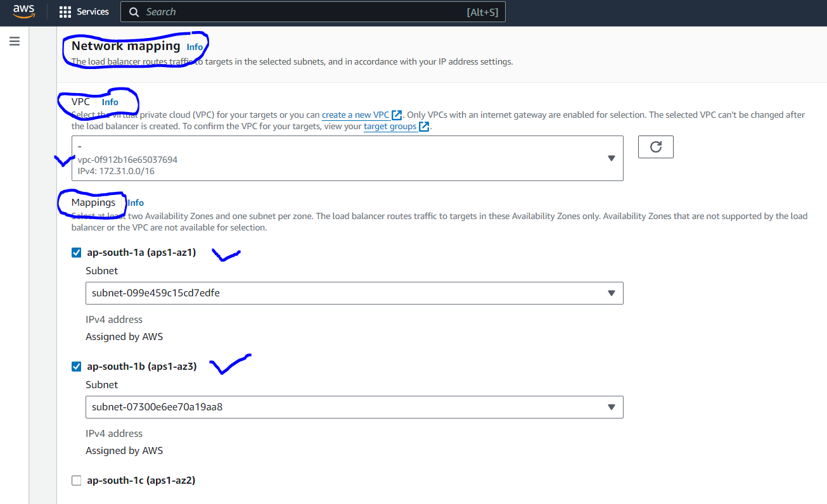

1. Then goto **Security Groups** and select your security group.

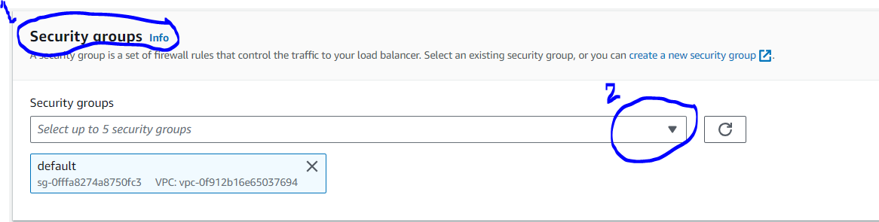

1. Then goto **Listeners and routing, in** Protocol select **protocol** based on your requirement (for spring boot application select HTTP or HTTPS), we need security so we need to select https.
2. Then in **port** enter port number of HTTPS.
3. Then In **Default action** select **Target Groups** which you have created(this is must to do step)

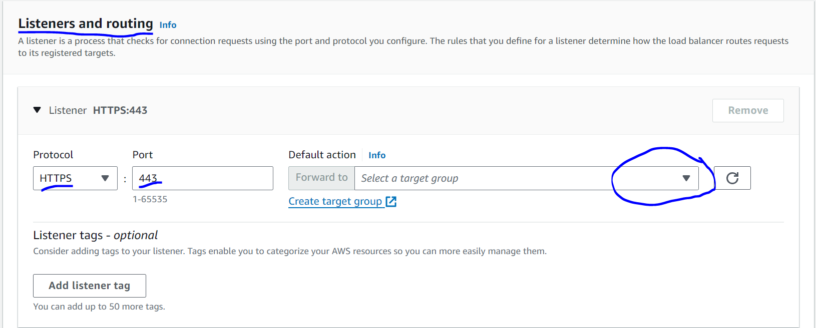

1. Then goto **Secure listener settings.**
2. Then goto **Security policy** and don’t changes anything, leave it default whatever is selected.
3. Then goto **Default SSL/TLS server certificate, In** Certificate source select From ACM.
4. Then goto **Certificate (from ACM)** and from dropdown select certificate which you have created from ACM.

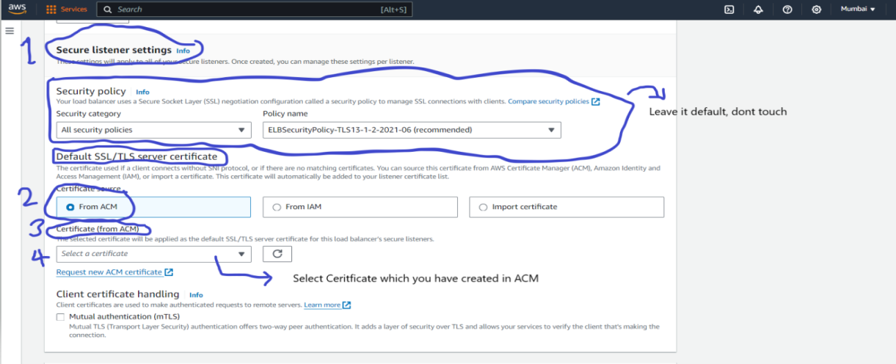

1. Then goto **Summary** to verify configuration which you have select.

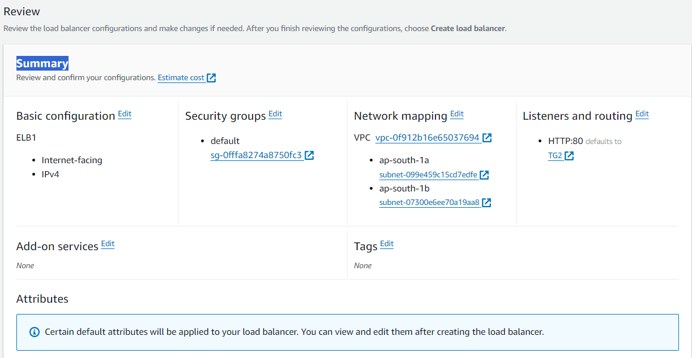

1. Then click **Create load balancer**.